For this campaign we suggest that you write a simple card or greeting to the individual saying, for instance, that you are thinking of him/her and/or urging them not to lose hope ― or words to that effect. A picture postcard is always welcome and cheapest to send. You can include your name and address if you wish but do not mention ACAT or include a religious greeting or motif if so advised, since communication from a foreign organisation can endanger the prisoner. Several individuals featured in previous campaigns have been released. Sadly others are still in prison and it is important to send regular greetings to ensure they are not forgotten. Changes in their circumstances are described, where known. As usual we include human rights groups. For individual prisoners or their families it is heartening to receive fairly regular cards of encouragement. Members should not feel obliged to respond to every appeal case or to write to all the addresses listed for a particular case. Postage overseas is expensive: a letter or card (e.g. postcard) weighing up to and including 100g costs £2.80.

**GROUPS**

**Aida Youth Centre** is a community-based organisation located in Aida Camp, a refugee camp located just outside the 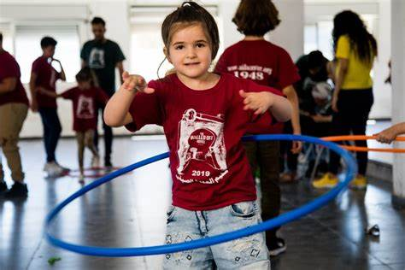city of Bethlehem, in the West Bank. The organisation was founded in 1968 to serve and protect the local refugee community, especially its children and young people. It provides support and education alongside sports and workshops and activities in the arts. It also provides direct humanitarian aid to the community when needed and engages in advocacy to protect the rights of Palestinian refugees and educate others about their plight. Aida Refugee Camp was established in 1950 for around 1,200 Palestinian refugees fleeing their villages. Today, the number of refugees has increased to more than 5,500 people, while the area of the camp remains just 0.071 sq. km. *You can also* send a personal greeting to Anas Abu Srour, Executive Director of the Centre, who was detained by the IDF in 2023 (see below).

**Please send a greeting to:**

El-Bandak Street, Aida Camp, Bethlehem

Palestinian Territories

Email: [info@aidacenter.org](mailto:info@aidacenter.org)

Website: <https://www.aidacenter.org>.

**Refugee Roots** is a Christian charity that helps asylum-seekers and refugees build relationships and navigate the complexities of beginning a new life in the UK. Launched in 2001 as The Rainbow Project, based on the vision of St Stephen's Church, Hyson Green, Nottingham. Refugee Roots continues to be motivated and inspired by Christian faith. Its range of initiatives include providing information, advice and guidance, befriending and accompanying asylum-seekers to appointments, as well as offering supportive groups and activities, such as free English conversation classes.

**You can send a greeting to:**

Refugee Roots

Suite 53, Unit 6, Sneinton Market

Gedling Street

Nottingham

NG1 1DS

Email: [info@refugeeroots.org.uk](mailto:info@refugeeroots.org.uk)

Website: <https://www.refugeeroots.org.uk>

*****

**INDIVIDUALS**

**Please send a greeting to Anas Abu Srour, Palestine.**

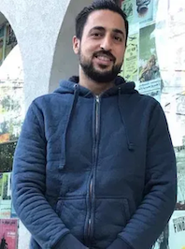In December 2023 Anas Abu Srour, executive director of a youth club in Aida refugee camp near Bethlehem, was arrested by the Israeli authorities and detained without charge. In August he was released after serving nine months of brutal 'administrative detention' in several prisons. In the following extract (published by Al Jazeera in October 2024) he describes his ordeal:

*As an administrative detainee, I – like the rest of the 10,000 Palestinian political prisoners – experienced inhumane prison conditions designed to cause maximum suffering. For over eight months, I was starved, humiliated, insulted and beaten by Israeli forces. I was held with 11 other detainees in a small concrete cell meant for five. It felt like we were being suffocated alive, like we were being kept in a mass grave. It was hell on Earth. The guards would walk around with heavy protective gear, beating us regularly with sticks, hands and feet. They would unleash large police dogs to terrorise us. They would bang their batons nonstop on the metal bars of the cells or other metal objects, not giving us a moment of peace. They would insult us constantly, cursing the women in our lives, degrading our mothers, sisters, daughters and wives, and referring to the detainees as subhuman. They would also insult and degrade national symbols like Palestinian leaders, slogans and our flag, trying to degrade our very identity as Palestinians. We had no privacy, except for the brief moment we were allowed to use the toilet and we were not permitted to shave for the first six months. The amount of food provided was less than what is necessary for an adult to stay alive. I lost more than 20 kilogrammes while in detention.*

**Please send a (religious or non-religious) greeting (you can mention ACAT) to:**

Mr Anas Abu Srour

El-Bandak Street, Aida Camp, Bethlehem

Palestinian Territories

Email: [info@aidacenter.org](mailto:info@aidacenter.org)

Website: <https://www.aidacenter.org>

*****

**Please send a greeting to Osama Yassin (and others), Egypt.**

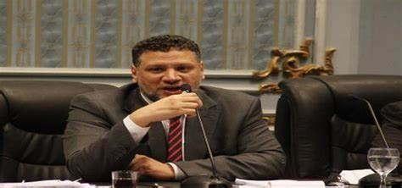Osama Yassin was sentenced to death on 4 March 2024 by Egypt's Supreme Emergency State Security Court. This was part of a mass trial involving several opposition figures, including other leaders of the Muslim Brotherhood. The trial, which has been criticised for its lack of fairness and allegations of torture, resulted in death sentences for eight leading members of the opposition, including Yassin. Human rights organisations have condemned the trial as politically motivated and have called for the defendants' release. Osama Yassin is currently held in Tora Prison, a high-security facility in Cairo which is known for its harsh conditions and has been the site of numerous human rights violations. The other prisoners are **Mohammed Badie**, **Mahmoud Ezzat**, **Mohamed El-Beltagy**, **Amr Mohamed Zaki**, **Safwat Hegazy**, **Assem Abdel Majed**, and **Muhammad Abdel Maqsoud**. Yassin was a former government minister (for youth) and several others were members of parliament.

**Note**: The notorious Tora Prison Complex is very large, consisting of several sites. It is not certain that the prisoner will receive your greeting, but in our view it is worth attempting.

**Please send a non-religious greeting (do not mention ACAT) to:**

Name of prisoner

Tora Prison Complex

Cairo

Egypt

*****

**Please send a greeting to Mohammad al-Halabi, Palestine/Israel.**

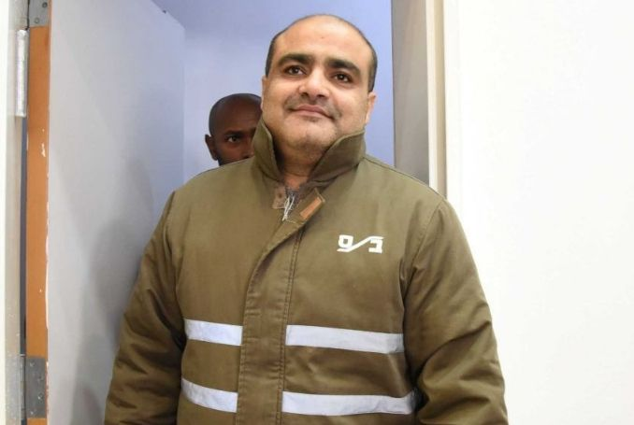Mohammed al-Halabi is a Palestinian aid worker, husband and father. Following a deeply flawed legal process and charges that remain unsubstantiated, Mohammed was sentenced in August 2022 to 12 years in prison after having spent the previous six years in detention. In 2005 he started working for the charity World Vision. In 2014, he was promoted to manage the charity’s operations in the Gaza Strip. It was there that he was convicted of diverting millions of dollars in aid ― much donated by the Australian Government ― to Palestinian armed groups.

Israeli authorities interrogated Mohammed without legal representation. He was allegedly tortured and tried in secret hearings and convicted on secret evidence that heavily relied on a coerced statement that neither Mohammed nor his lawyer were allowed to access. Both World Vision and the Australian Department of Foreign Affairs and Trade conducted external, comprehensive audits of Mohammed’s work. Neither of them found evidence that any funds were diverted.

**Please send a non-religious greeting (you can mention ACAT) to:**

Mohammad al-Halabi

C/o Po Box 699

Mitzpe Ramon

8065502

Israel

*****

**Please send a greeting to Qaisar and Amoon Ayub, Pakistan**.

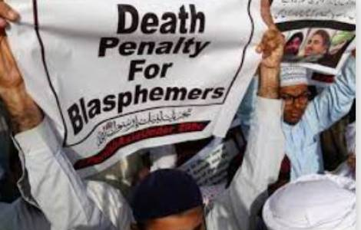Two Christian brothers, Qaisar and Amoon Ayub from Lahore, were arrested in 2014/15 after one of the two was accused of posting offensive material against Islam on their website. Qaisar and his wife Amina have three children, whilst Amoon is married to Huma, a teacher at Lahore Cathedral School. The allegations surfaced in 2011 when they were accused of posting disrespectful material on their website. The accused say that their website was not active after 2009. Sentenced to death, their appeals were dismissed in June 2022, despite the lack of concrete evidence against them. The brothers continue to maintain their innocence and claim that they did not create the blasphemous content. [Picture: fides.org]

**Please send a (non-religious) greeting (do not mention ACAT) to:**

Qaisar and Amoon Ayub

Jhelum District Jail

Near Kachehri

Jhelum

Pakistan

*****

**Please send a greeting to Dieudonné Niyonsenga, Rwanda.**

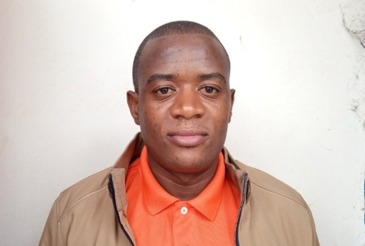Dieudonné Niyonsenga, also known as Cyuma Hassan, is a journalist currently serving a seven-year prison sentence in Rwanda. He has reported being tortured and held in inhumane conditions, including two weeks in solitary confinement, while in pre-trial detention. During a court hearing on 10 January 2024, he appeared with visible injuries and claimed that his hearing and vision were impaired due to the harsh conditions. He was first arrested in April 2020 and detained for several weeks on allegations of fraud after he, alongside other journalists, reported critically on the impact of COVID-19 guidelines on vulnerable populations. These charges were eventually dropped, but he was rearrested in October 2021 as part of a crackdown on opponents and critics of the government and charged with “membership in a criminal group”, “dissemination of false information or propaganda with intent to cause a hostile international opinion against Rwanda’s government”, and “spreading rumours”. On 21 November 2021 he was sentenced to seven years, upheld in March 2024. [Picture: John Williams Ntwali]

**Please send a (religious or non-religious) greeting (you may mention ACAT) to:**

M. Dieudonné Niyonsenga

Mageragere Prison (Nyarugenge Correctional Facility)

Nyarugenge District

Mageragere Sector

Kigali

Rwanda

*****

**Please send a greeting to Déogratias Mushayikdi, Rwanda.**

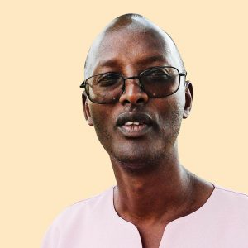Déogratias Mushayikdi was sentenced to life imprisonment in 2010 after being extradited from Tanzania. As a Tutsi, he lost his family during the 1994 genocide and was representative in Switzerland of the Rwandan Patriotic Front (RPF), the armed rebellion in which Paul Kagame – current president of the Republic – was one of the leaders. After the war he worked for the RPF in Rwanda but left his post on discovering that the Front committed extra-judicial killings with impunity. He then worked as a journalist, criticising the abuses of the RPF. After exile in Belgium and Tanzania he was extradited to Rwanda in 2010, where he was quickly tried without testimony and sentenced to life imprisonment for causing state insecurity, inciting the population to hate the government, and using forged documents. Imprisoned now for 15 years, his situation has been largely forgotten and, with no family in Rwanda, he receives few visits.

**Please send a (religious or non-religious) greeting (you may mention ACAT) to:**

M. Déogratias Mushayikdi

Kigali Central Prison (1930)

Nyarugenge District

Kigali

Rwanda

*****

**Please send a greeting to Mohamed Boughalleb, Tunisia**

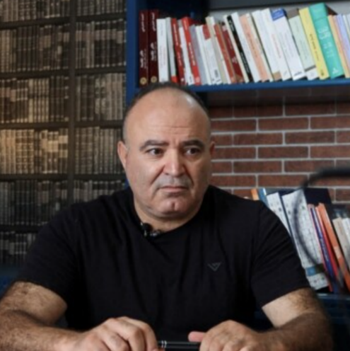Mohamed Boughalleb, a prominent Tunisian journalist, has been arbitrarily detained since his arrest by security forces on 22 May 2024. His arrest followed a complaint from a senior official of the Ministry of Religious Affairs (MRA) based on comments Mohamed made publicly on his social media page, as well as on TV and radio shows, accusing the MRA of poor governance and corruption. Despite having completed his unjust eight-month prison sentence, Mohamed remains arbitrarily detained in connection with a separate case under Decree-Law 2022-54 on Cyber Crimes. He faces charges for ‘using telecommunications networks to produce, send, or disseminate “fake news” or “rumours” to harm, defame, or incite violence against others. These charges stem from a complaint filed by a professor who claimed that Mohamed “insulted” her on Facebook. Mohamed has consistently maintained that the alleged comments were not made from his account.

Mohamed’s health has severely deteriorated during his unjust imprisonment. He suffers from chronic illnesses, including diabetes and high blood pressure, and has developed prostate problems. His diabetes has worsened, triggering repeated infections, and his eyesight and hearing are now severely affected. Despite his critical condition, he has not been granted access to adequate medical care, including his daily medication and regular medical check-up. On 4 November 2024, he was reportedly transferred to another wing of El Mornaguia prison, where conditions are even worse due to overcrowding. Mohamed’s ongoing detention, lack of medical care, and worsening health amount to ill-treatment under international law. According to Middle East Eye, journalists and politicians in Tunisian prisons are suffering from medical negligence and abusive treatment. The National Union of Tunisian Journalists (SNJT) also reports that Mohamed has been barred from corresponding with his family.

Since May 2024 Tunisian authorities have intensified their crackdown on media freedom. Two other prominent journalists, Borhen Bsaies and Mourad Zeghidi, were sentenced to one year in prison under Article 24 of Decree-Law 2022-54 on Cyber Crimes in separate cases. Since its enactment in September 2022, this law has been weaponised against individuals exercising their right to freedom of expression, violating Tunisia’s obligations under international human rights treaties.

**Please send a greeting (non-religious, do not mention ACAT) to:**

Mohamed Boughalleb

Prison El Mornaguia

Sidi Ali El Hattab, PXRF+MW

Tunisia

*****

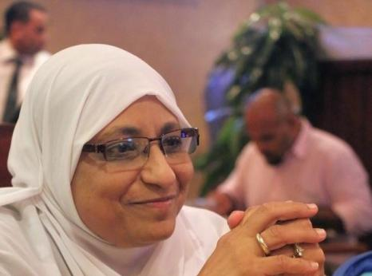**Please send a greeting to Hoda Abdelmoniem, Egypt.**

Hoda Abdelmoniem, an Egyptian human rights lawyer, activist, and board member of the Egyptian Coordination for Rights and Freedom, was arbitrarily arrested in November 2018 without a warrant. She was subjected to enforced disappearance for three weeks before being brought before the Supreme State Security Prosecution (SSSP) for investigation.

Hoda was due for release on 31 October 2023 after completing a five-year prison sentence handed down by an Emergency State Security Court (ESSC) in a grossly unfair trial on terrorism and other bogus charges. Instead, she was interrogated by an SSSP prosecutor in connection with a separate case and placed in pretrial detention. Her detention was last renewed for 45 days on 5 November 2024 in an online hearing. Hoda remains in poor health due to severe physical and psychological torture.

Held in a cramped cell in 10th Ramadan prison with one other person, Hoda is allowed outside for only one hour, six times a week, in a corridor with no sunlight. She is prohibited from exercising alongside other prisoners, preventing social interaction. While most prisoners receive monthly visits, her family was only allowed to see her six times in 2024 and was denied access on three occasions. During a visit on 28 August 2024, Hoda revealed she had been diagnosed with diabetes and was receiving medication from the prison hospital. On 9 October 2024, her family noticed she had lost a significant amount of weight. She requested their help in consulting an external doctor regarding her diabetes and kidney disease, but the prison authorities continue to deny Hoda and her family access to her medical records and refuse to transfer her to an external hospital for specialised care. Her health has been deteriorating throughout her detention. She suffers from peripheral neuropathy, causing severe pain, numbness, and electric shock-like sensations, as well as an ear infection that affects her balance and vision.

Hoda’s continued detention ― more than a year after her sentence expired ― alongside that of other human rights lawyers and activists is a blatant violation of the rule of law and highlights the security apparatus’s interference in judicial affairs in Egypt.

**Please send a greeting (do not mention ACAT) to:**

Hoda Abdelmoniem

10th of Ramadan Prison

Al-Sharqia Governorate 7062901

7PF7+4RJ

Egypt

*****

**Please send a greeting to Behrouz Ehsani and Mehdi Hassani.**

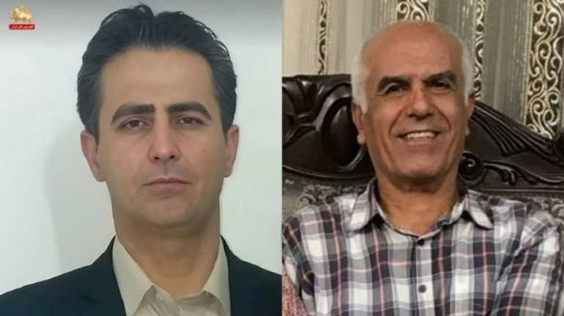Behrouz Ehsani and Mehdi Hassani face imminent execution in Iran after being sentenced to death on charges of “armed rebellion against the state” (*baghi*), “enmity against God” (*moharebeh*), and “corruption on earth” (*efsad-e fel-arz*), over their alleged links to the banned People’s Mojahedin Organisation of Iran (PMOI). Their conviction followed a grossly unfair trial on 10 August 2024 before Branch 26 of the Revolutionary Court in Tehran, which lasted just five minutes. They were denied legal representation for nearly two years, and their torture allegations were ignored. Both individuals deny all charges.

On 26 January 2025, authorities secretly transferred them from Evin prison to Ghezel Hesar prison in Alborz Province - where prisoners are often moved before execution. No information has been given to their families or lawyers since, raising urgent concerns that they may be executed at any moment.

During interrogations, both men were subjected to severe torture and ill-treatment. Behrouz was held in solitary confinement for fifty days in Evin’s Section 240, where agents tried to force a “confession” through psychological torture, including threats of execution, flogging, and harm to his family. He was then moved to Section 209 for another seventy-five days before being placed in the general ward. Mehdi was kept in solitary confinement for six months, during which he was severely beaten and forced to write self-incriminating statements under duress. Both were denied family contact for months.

Iranian authorities have intensified their use of the death penalty to crush dissent. Amnesty International recorded at least 853 executions in 2023, a 48% increase from 2022. The execution spree has continued in 2024, targeting protesters, dissidents and ethnic minorities after sham trials. The true number of executions is likely to be far higher due to government secrecy.

**Please send a greeting (non-religious, do not mention ACAT) to:**

Behrouz Ehsani

Ghezel Hesar Prison

Alborz Province, Karaj, Mehrshahr

Payam Road

RV24+R92

Iran

**And to:**

Mehdi Hassani [address as above]

*****

**Please send a greeting to Yashar (Yaxia’er Xiaohelaiti**), **China**

Yashar, a 26-year-old Uyghur songwriter and musician, was residing in Chengdu, Sichuan province, before his detention on 11 August 2023 by municipal authorities. He was charged with “promoting extremism” and “illegally possessing extremist materials” due to music by him being published online and his possession of Uyghur-language books. Many of these books are regarded by Uyghurs as classic literature, essential to understanding their history and culture. On 20 June 2024, Yashar was sentenced to a three-year prison term, underscoring the ongoing repression of Uyghurs for engaging in cultural expression.

Yashar suffers from chronic bronchitis and is reportedly in serious health danger due to inadequate medical care. His condition requires regular medication, but it is widely believed that he is not receiving the necessary treatment, raising grave concerns for his well-being. The denial of adequate medical care constitutes ill-treatment that may amount to torture under international human rights law. Human rights advocates argue that these charges are part of a broader crackdown on Uyghur cultural expression under the guise of countering terrorism and extremism. Yashar’s case highlights the increasing risks faced by Uyghur artists, many of whom are targeted simply for expressing their ethnic identity through music, literature, and other cultural outlets. Many in the Uyghur community live in constant fear of arrest for expressing their cultural identity, leading to widespread self-censorship. [See the article ‘Waiting to be Arrested at Night’ in the September – November 2024 Newsletter.]

**Please send a greeting (non-religious, do not mention ACAT) to:**

Yashar (Yaxia’er Xiaohelaiti)

Wusu Prison

Wusu City, Tacheng Prefecture

Xinjiang Uyghur Autonomous Region

People’s Republic of China

*****

**Please send a greeting to Verisheh (Wrishe) Moradi, Iran.**

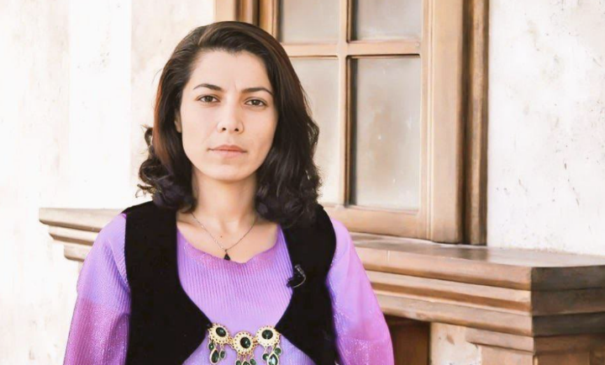A member of the East Kurdistan Free Woman Society (KJAR), Verisheh Moradi faces execution in Iran following a grossly unfair trial. She was violently arrested on 1 August 2023 in Sanandaj, Kurdistan Province, and forcibly disappeared for nearly four months before being sentenced to death in November 2024 by Branch 15 of the Revolutionary Court in Tehran. Convicted of “armed rebellion against the state” (*baghi*) over alleged links to Kurdish opposition groups, she has consistently denied the charges, and her appeal is currently pending before the Supreme Court.

In an August 2024 open letter from prison, Verisheh detailed the severe torture and gender-based violence she endured during detention. Initially held in a Ministry of Intelligence detention facility in Sanandaj for 13 days in solitary confinement, she was then transferred to Section 209 of Evin Prison in Tehran where she was subjected to four months of prolonged solitary confinement and interrogated without legal representation. Iranian intelligence agents threatened her with execution and used psychological and physical coercion to extract forced “confessions” alleging she took up arms against the government ― claims she has repeatedly refuted.

Verisheh’s pre-existing intestinal health issues worsened after a three-week hunger strike in October 2024, yet authorities continue to deny her adequate medical care. Since May 2024, prison officers have barred her family from visiting and severely restricted communication with her loved ones.

Following the “Woman Life Freedom” uprising, Iranian authorities have intensified executions in order to instil fear and suppress dissent, disproportionately targeting ethnic minorities, including Kurds. Amnesty International has repeatedly documented how Kurdish individuals are arbitrarily detained and sentenced to death without sufficient evidence of criminal wrongdoing, often solely due to real or perceived affiliations.

**Please send a greeting (non-religious, do not mention ACAT) to:**

Verisheh (Wrishe) Moradi

Evin Prison, women’s ward

Q9WP+99 Tehran

Tehran Province

Iran

*****

**Please send a greeting to Nguyen Van Duc Do, Vietnam.**

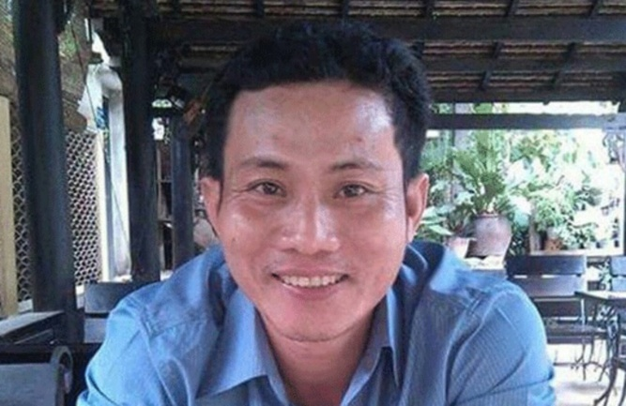Nguyen Van Duc Do, an electrician originally from Huẽ city, was arrested on 6 November 2016 in Ho Chi Minh City due to his alleged membership in the “Coalition of Self-Determination for Vietnamese People” and his participation in protests following the Formosa environmental disaster. On 5 October 2018, the People’s Court of Ho Chí Minh City convicted him under Article 79 of the 1999 Penal Code (“carrying out activities aimed at overthrowing the people’s administration”) and sentenced him to 11 years’ imprisonment. Since May 2020, Nguyen has been subjected to prolonged solitary confinement and has endured severe mistreatment amounting to torture, in violation of Vietnam’s Constitution and its international human rights obligations.

Nguyen has suffered prolonged torture and ill-treatment. In solitary confinement his legs were chained for 10 consecutive days, leading to severe swelling, open wounds, and infection. Meanwhile he was reportedly given food contaminated with human excrement and dirty water, which caused food poisoning and illness. Despite suffering serious health complications, he has been denied adequate medical treatment.

On 16 March 2021, during a family visit, relatives were informed that prison guards had set a guard dog upon him the previous day as an act of retaliation after he banged on his cell door in protest against his prolonged solitary confinement and worsening health. While it is understood that Nguyen was not bitten, the psychological trauma severely impacted his mental well-being. Pushed to desperation, he has since urged his family to petition the State President to end his life, stating that he “cannot continue living under current circumstances”.

Vietnam has ratified the UN Convention against Torture (UNCAT), and its Constitution explicitly prohibits torture. However, the Vietnamese authorities have failed to amend the Criminal Code and Criminal Procedure Code to explicitly criminalise torture in accordance with UNCAT Article 1(1). The treatment inflicted upon Nguyen constitutes a clear violation of international human rights law, including the absolute prohibition of torture and cruel, inhuman, or degrading treatment or punishment. The denial of medical care, prolonged solitary confinement, and psychological intimidation amount to serious human rights abuses.

**Please send a (religious or non-religious) greeting (you can mention ACAT) to:**

Nguyen Van Duc Do

Xuân Lộc Prison

XCQ3+5HQ

Suối Cao

Xuân Lộc, Dong Nai

Vietnam

*****

**Please send a greeting to So’ada Khadirzadeh, Iran.**

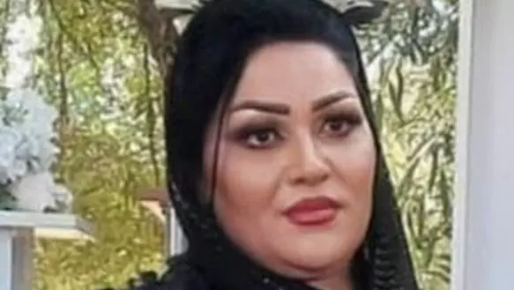So’ada Khadirzadeh, a Kurdish Iranian woman, was approximately six weeks pregnant when arrested on 14 October 2021 in Piranshahr, West Azerbaijan Province. Following her arrest, she was subjected to an enforced disappearance of 25 days. Her family was denied information about her whereabouts until her transfer to Urumieh Central Prison on 8 November 2021. So’ada was charged with “membership of a group with the purpose of disrupting national security”, allegedly referring to the Democratic Party of Iranian Kurdistan, and being an accessory to murder ― charges she has repeatedly denied.

In December 2021, prison doctors recommended specialised medical care outside the prison due to her health condition, but authorities denied this access. On 26 April 2022, So’ada initiated a 12-day hunger strike to protest her continued detention and lack of necessary medical care. During this period, she also refused medication. In a leaked audio message during her hunger strike, So’ada revealed that Ministry of Intelligence agents had forcibly disappeared her post-arrest, subjected her to intense interrogations, verbal abuse, and “immoral suggestions”. She described herself as being held “hostage”, implying that agents were detaining her to compel her husband to return to Iran. She ended her hunger strike after officials promised her release on bail, a promise that was not fulfilled.

Hours after giving birth, authorities transferred her and her newborn back to Urumieh Central Prison, against medical advice. Since then, she has relied on fellow inmates to help care for her child due to inadequate prison accommodations. Reports indicate that both mother and child have been denied adequate nutrition and medical care, exacerbating their health issues. As of August 2024, So’ada and her child remain in prison under harsh conditions.

International human rights organisations have documented systematic violations of fair trial rights in Iran, including arbitrary arrests, prolonged solitary confinement, and denial of medical care. The treatment of So’ada and her child exemplifies these abuses and highlights the urgent need for intervention to ensure their health and well-being.

**Please send a greeting (non-religious, do not mention ACAT) to:**

So’ada Khadirzadeh

Urumieh Prison

West Azerbaijan Province

H47M+G58

Iran

*****

**Please send a greeting to Anar Mammadli, Azerbaijan.**

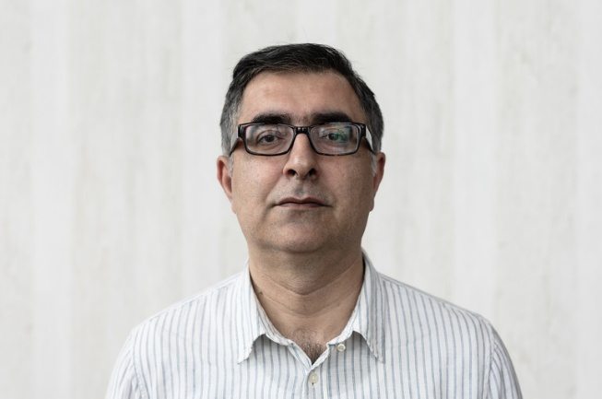Anar Mammadli, a prominent human rights defender and head of the Election Monitoring and Democracy Studies Centre in Azerbaijan, was arrested on 29 April 2024 on charges of “smuggling by a group” under Article 206.3.2 of the Azerbaijani Criminal Code. Following his arrest, law enforcement officers conducted simultaneous raids on his residence and his parents’ home, seizing documents, laptops, and flash drives. Relatives suspect that authorities may have planted unidentified sums of money during these searches.

Since his detention, Anar’s health has significantly deteriorated. He suffers from arthritis, stomach cramps, headaches, shortness of breath, and a persistent cough. Despite these serious symptoms, authorities have repeatedly denied him access to proper medical examination and essential healthcare. If these health concerns remain unaddressed, they may have irreparable effects on his physical and mental well-being. The state has a duty under international human rights law to uphold the right to health of individuals kept in places of detention. Notably, the UN Standard of Minimum Rules for the Treatment of Prisoners emphasises the state’s responsibility for healthcare and affirms that people in prisons should be afforded the same standard that is available in the community.

The arrest and detention of Anar are part of a broader crackdown on human rights defenders and journalists in Azerbaijan. Since October 2023, authorities have detained at least thirteen independent journalists, including those from the Abzas Media outlet. These individuals are being investigated for “conspiring to bring money into the country unlawfully”, as described in Article 206.3.2 of the Criminal Code.

Reports have emerged about alleged torture, ill-treatment, and other violations of the rights of detainees in Azerbaijan. Civil society groups estimate that the number of political prisoners in the country currently stands at over 288. The detention of Anar follows a pattern of abuse of the criminal justice system aimed at silencing government critics, including illegal searches, denial of access to lawyers, and arbitrary detentions.

**Please send a (religious or non-religious) greeting (do not mention ACAT) to:**

Anar Mammadli

Baku Detention Center No.1

Nizami District

Narimanova Muzaffara Street

1 AZ-1029

Azerbaijan

*****

**REMEMBER IN YOUR PRAYERS**

**Prageeth Ekneligoda**, cartoonist, journalist and government critic, who disappeared in 2010. There are fears for his safety.

**Dr Hussam Abu Safiya**, a prominent advocate of healthcare in Gaza, arbitrarily detained and held incommunicado in December 2024.

**Sonia Dahmani**, imprisoned, cruelly treated and denied medical treatment after criticising the misuse of prison in Tunisia.

**Pakhshan Azizi**, aid worker and civil activist, tortured and sentenced to death in Iran.

*We remember also the many prisoners of conscience and pray that, through being in our thoughts and prayers, they gain hope and encouragement*.

